The Exonian User Manual

**Section 1: Installing the Application**

This should be no different from the examples from the Android book. Simply import the Exonian project into the workspace and then do “Run As Android Application”. Within seconds on the device the activity should begin.

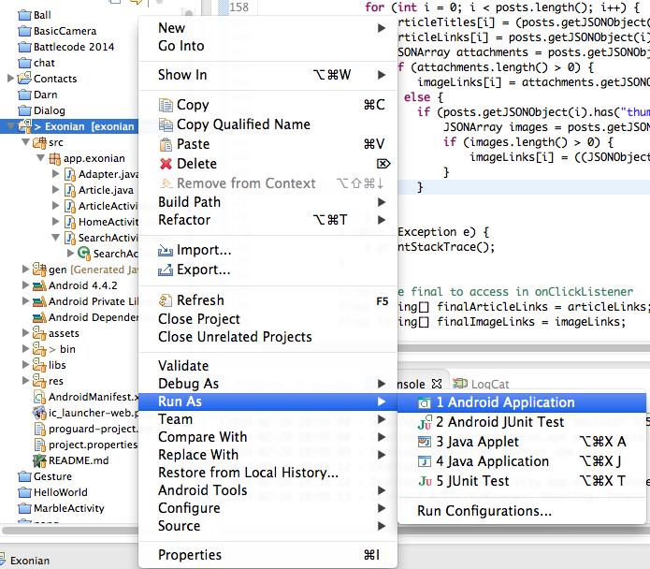

Make sure you have network access (such as Wi-Fi) on the device, otherwise you will get a message saying that the device is not connected to the Internet.

**Section 2: Navigating the Homepage**

The homepage, as you can see, has several pages which you can swipe back and forth horizontally to navigate. Those sections/pages correspond to the sections of the actual Exonian newspaper. You can click any article in the list of articles in each section to view it.

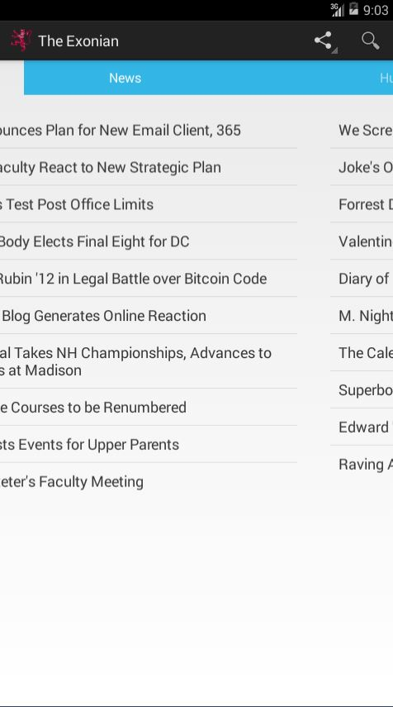

**Section 3: Viewing the Article**

Upon entering the Article window, the text (and picture if it exists) will be asynchronously loaded and should show up after a few seconds. If you revisit the same article a second time, the time will take significantly less because a local copy has been stored on the database. Simply scroll down to read the article. To go back to the homepage, click the back button on upper-left corner of the device.



**Section 4: Sharing an Article**

To share an article, first click on an article from the homepage. You should see a graph network button on the action bar which you can click. Also click “See more”. You will be given a lot of applications that can share the article URL, such as Facebook (if it is installed on the device) or G-Mail. Simply click on one of the applications and go through the posting process on that app. It will redirect you back when you are done (or if you click the back button on the device).



**Section 5: Searching for an Article**

In the home page, there is a magnifier button, which you can click to enter the search functionality. As you type, the app will search on the server for your search term. There may be a one or two seconds delay before the real time search results for the query to show up.

